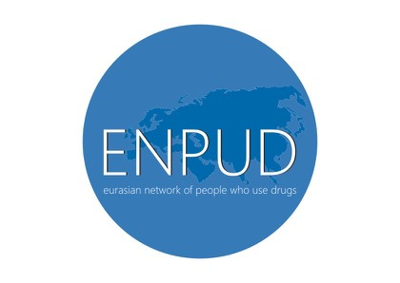
ЕВРАЗИЙСКАЯ СЕТЬ ЛЮДЕЙ, УПОТРЕБЛЯЮЩИХ НАРКОТИКИ EURASIAN NETWORK OF PEOPLE WHO USE DRUGS
e-mail: enpud.contact@gmail.com

PRESS RELEASE

Eurasian network of people who use drugs (ENPUD)
joins
International Overdose Awareness Day

Time to Remember, Time to Act

For all interested parties

August 31, the international community celebrates an important date - International Overdose Awareness Day. This is a global event that aims to raise awareness of overdose worldwide.

On this day, we remember people who died from an overdose of drugs, and situations when we or our friends remained alive thanks to timely assistance. The appeal, which is the main theme of the International Overdose Awareness Day, is “Time to remember, time to act”. This means that we must not only REMEMBER our loved ones and all those who died from overdoses, but also ACT, so that our friends no longer die from a drug overdose.

The number of overdoses in the world is only growing every year. And this is not about one-time cases, but about an increase in the number of overdoses associated with fatalities by tens of percent.

Non-fatal overdoses can leave drug users with significant health problems, such as muscle breakdown, kidney failure, heart problems, cramps, nerve damage, or cognitive impairment.

Most of the dead could be saved if someone was next to them, if this someone knew how to recognize an overdose, and most importantly - how to provide the necessary help. The infinite value of each person and the opportunity to save his life nullifies all fears, prejudices and stigma against people who use drugs.

Today, repressive drug policies in the Eastern Europe and Central Asia (EECA) region imply criminal liability for possession and, in some countries, for drug use. Criminalization drives people who use drugs into unsanitary and marginalized conditions, increasing the risk of contracting HIV and other diseases, as well as death from overdose. Criminalization also stops people from seeking medical attention in the event of an overdose of their friends or family members.

Obviously, such a policy is not able to prevent drug overdoses and deaths. It only increases the risk of premature death from overdose and the acute consequences of drug use. Throughout the world, the problem continues to worsen due to the emergence of new synthetic drugs - fentanyl and carfentanyl, which are many times stronger than heroin in their effects.

Today, one of our top priorities for ENPUD is the availability of NALOXONE. This is a medicine that can stop an overdose of opiates. In most EECA countries, naloxone is available only by prescription, which means that it is not at hand at the right time - in case of an overdose, the count is minutes. Other overdose prevention programs that have proven effective in our countries are also absent. Although experience shows that these measures are low-cost and help to save many thousands of lives and significantly improve the health of the population as a whole.

Many countries in the world are following the path of punitive drug policy reform, including developing overdose prevention programs and increasing the availability of naloxone among injecting drug users. Naloxone is removed from the prescription list, and also make it more accessible to consumers and social workers - they produce the drug in the form of a nasal spray.

To change the situation with overdoses in the EECA region, on August 31, activists from several countries will hold campaigns to attract the attention of the state and society to the problem of drug overdoses and possible solutions, in particular, the availability of naloxone to drug users.

Primary requirements:

• implementation of a consistent strategy to reduce overdose;
• the introduction of programs that expand access to naloxone among those whom it can save a life;
• the exclusion of naloxone from the list of prescription drugs;
• introduction of non-prescription nasal form of naloxone into the pharmacy chains.

Eurasian Network of People Who Use Drugs (ENPUD) joins to International Overdose Awareness Day. We urge all members of our network not to remain indifferent and to do everything possible to fulfill these requirements.

Time to act!



Contact Information:
Tatyana Kochetkova
Program coordinator
Eurasian Network of People Who Use Drugs (ENPUD)
dusya.kochetkova@gmail.com
+7 927 022 47 18

